### Introduction

### Introduction: Transforming Financial Transactions in Abbigere

In a forward-thinking initiative to promote financial inclusivity and modernize economic transactions, a dedicated group of college students set forth to Abbigere, a dynamic locality in the heart of Bangalore.

Equipped with a collective vision of digital financial empowerment and a commitment to fostering a cashless society, our team launched an awareness campaign advocating for the adoption of Digital Money. Abbigere, with its unique mix of urban vibrancy and community spirit, provided the perfect backdrop for our mission.

Recognizing the transformative potential of digital transactions in enhancing financial security and efficiency, our campaign aimed to instill a deep understanding of the benefits of Digital Money.

The focal point of our efforts was the demonstration of digital wallets and mobile banking applications, encouraging the community to embrace these modern financial tools. Beyond the practical aspects, our endeavor sought to highlight the importance of digital literacy as a means to empower individuals economically, increase transparency, and contribute to the overall development of the community.

This introduction captures the essence of our initiative—a collective journey to inspire financial transformation, one digital transaction at a time, in the bustling locality of Abbigere.

Together, we strive for a future where financial transactions are seamless, secure, and inclusive, fostering a community that embraces the advantages of Digital Money and thrives in the digital age.

## Promoting Digital Money in Abbigere, Bangalore

### Objective:

The primary objective of our financial awareness campaign in Abbigere, Bangalore was to advocate for digital financial practices by promoting digital money usage, aiming to foster financial inclusion and contribute to the overall economic empowerment of the community.

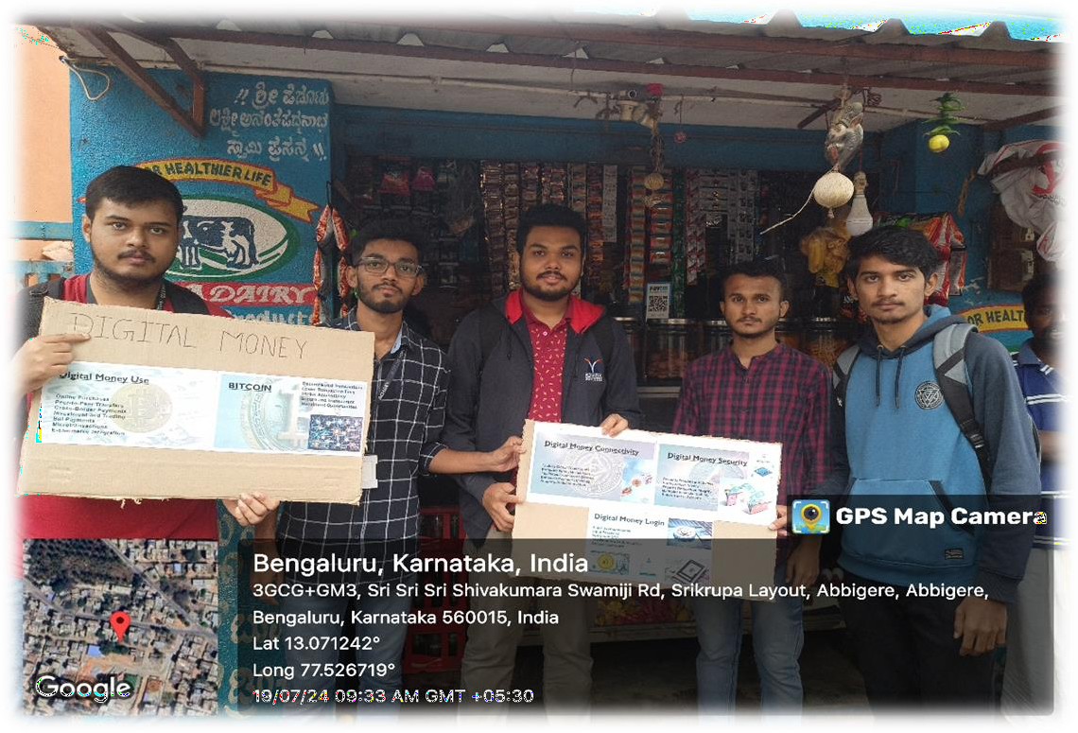

### Specific Goals:

1. **Digital Money Promotion:** Encourage the use of digital payment methods extensively in Abbigere to replace cash transactions, aiming to increase financial security and convenience.
2. **Raise Awareness:** Educate the local community about the advantages of digital money, emphasizing the importance of transitioning to digital financial services for economic empowerment.
3. **Digital Literacy:** Promote digital literacy initiatives by distributing informational materials and engaging in conversations that highlight the critical role of digital skills in today's economy.
4. **Behavioral Change:** Encourage a tangible shift in financial behavior, inspiring individuals to choose digital payments over cash, thereby contributing to a more secure and efficient financial system.
5. **Community Engagement:** Foster a sense of shared responsibility within the community, creating a dialogue about digital financial practices and motivating residents to actively participate in the digital economy.
6. **Economic Growth:** Highlight the role of digital money in fostering economic growth and development, encouraging local businesses to adopt digital payment methods.
7. **Security Awareness:** Educate the community about the security benefits of digital transactions, reducing the risk of theft and fraud associated with cash handling.

By addressing these objectives, our aim was not only to provide a practical alternative to cash but also to catalyze a broader cultural shift towards digital financial inclusion. Through these efforts, we sought to contribute to the broader mission of creating a more inclusive and secure financial future for our community.

### Participants:

A dedicated group of college students passionate about technology and financial inclusion actively participated in the campaign. The team engaged with the local community, spreading awareness about the benefits of digital money and promoting the advantages of adopting digital payment methods.

### Activities:

1. **Promotion of Digital Payments:** The team promoted digital payment methods at key locations in Abbigere, emphasizing their advantages over cash transactions. Each interaction carried a message encouraging residents to switch to digital money for their financial security and convenience.
2. **Community Engagement:** Interactions with local residents were a significant aspect of our campaign. The team engaged in discussions, providing insights into the benefits of digital financial services and the positive implications of using digital money.
3. **Digital Literacy Awareness:** To underline the importance of digital literacy, informational pamphlets accompanied the digital money promotion. These pamphlets highlighted the role of digital skills in empowering individuals and fostering economic growth.

### Response and Impact:

The response from the community was overwhelmingly positive. Residents expressed a heightened awareness of the benefits of digital money and a genuine interest in adopting digital payment methods. Many community members pledged to increase their use of digital transactions and actively participate in digital literacy initiatives.

### Positive Community Engagement:

Residents of Abbigere exhibited a commendable willingness to engage in discussions about the advantages of digital money. Conversations were marked by genuine curiosity, with many expressing a newfound understanding of the importance of transitioning towards digital financial services.

### Adoption of Digital Payments:

The promotion of digital payment methods yielded tangible results as residents actively incorporated them into their daily lives. Many community members enthusiastically embraced the shift from cash, recognizing the positive implications for financial security and convenience.

### Digital Literacy Pledges:

Our campaign's emphasis on digital literacy resonated deeply with the community. Informational pamphlets distributed alongside the digital money promotion sparked discussions about the critical role of digital skills, leading to pledges from residents to support local digital literacy initiatives.

### Behavioral Change:

The campaign has catalyzed a noticeable behavioral change within the community. Individuals are making conscious decisions to reduce their reliance on cash, contributing to a more secure and efficient financial system. The sight of residents proudly using digital payment methods has become a symbol of a collective commitment to financial inclusion.

### Educational Impact:

Beyond immediate actions, the campaign has left a lasting educational impact. Awareness about the benefits of digital money has grown, creating a community that is more informed and empowered to make digitally inclusive choices.

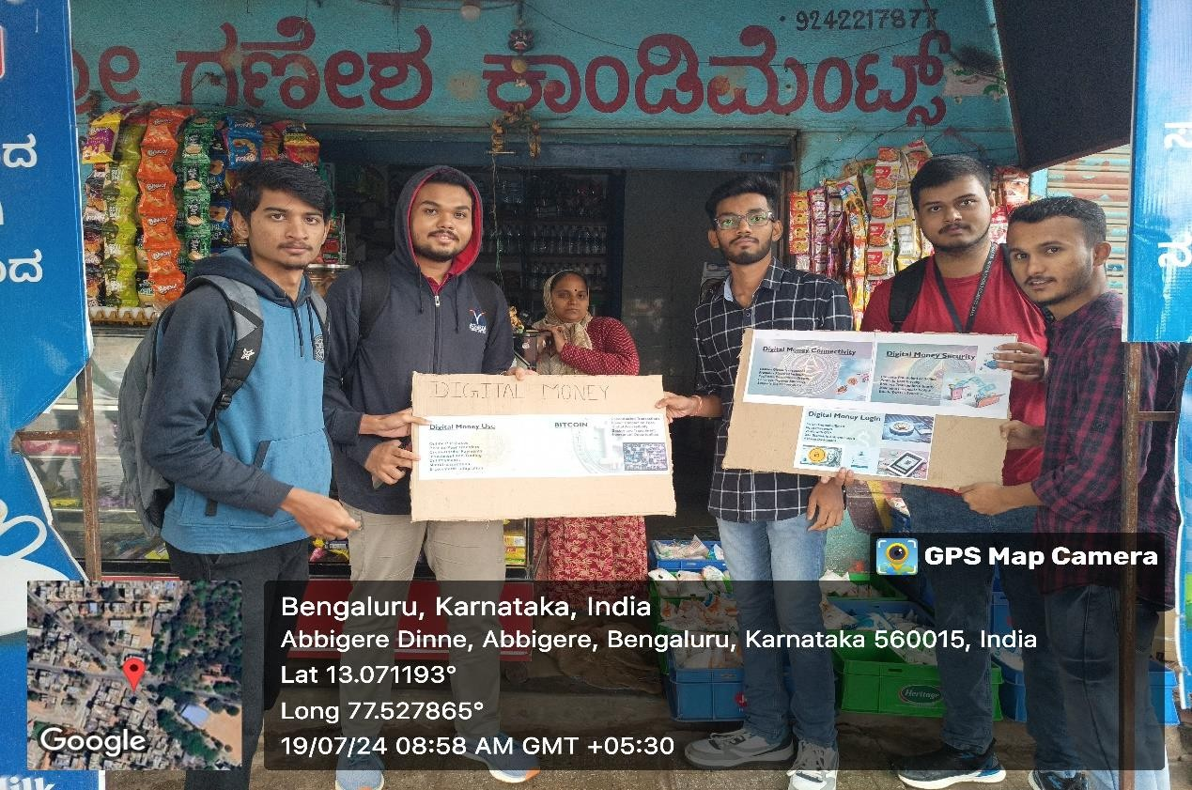

### Challenges:

While the majority of residents embraced the initiative, there were challenges in changing ingrained habits. Some individuals were initially resistant to the transition from cash to digital money. However, through open conversations and informative discussions, these challenges were effectively addressed.

### Challenges Faced:

1. **Behavioral Resistance:** Encouraging a shift from entrenched habits proved challenging. Some community members were initially resistant to adopting digital payment methods, emphasizing the need for persistent education to break through pre- existing norms.
2. **Limited Awareness:** Despite our efforts, a segment of the population in Abbigere exhibited limited awareness about the benefits of digital money. This underscored the importance of continued engagement and educational campaigns.
3. **Digital Literacy Barriers:** The promotion of digital money highlighted existing digital literacy barriers within the community. Addressing these barriers became a key focus, emphasizing the need for ongoing digital literacy initiatives.
4. **Technological Limitations:** Certain individuals faced technological limitations, such as lack of access to smartphones or reliable internet connectivity. These challenges highlighted the importance of bridging the digital divide.

### Overcoming Challenges:

Despite these challenges, our team employed various strategies to overcome them. We conducted interactive sessions, demonstrated the ease of digital transactions, and emphasized the security and convenience they offer. Through these efforts, we were able to address the concerns of hesitant individuals and inspire a gradual transition to digital money.

### Strategies Employed:

1. **Interactive Demonstrations:** Interactive sessions were held to demonstrate the ease of digital transactions, alleviating concerns and encouraging hesitant individuals to experience the process firsthand.
2. **Personalized Engagement:** Personalized interactions were key to addressing specific concerns. Tailored conversations and one-on-one engagements helped individuals overcome initial resistance and gain confidence in digital payment methods.
3. **Community Support:** Mobilizing community support was pivotal. By involving local influencers and community leaders in our campaign, we were able to build trust and credibility, fostering greater acceptance of digital money.
4. **Educational Materials:** Distribution of educational materials played a crucial role. Informational pamphlets, brochures, and digital literacy resources were provided to empower residents with the knowledge needed to embrace digital financial practices.
5. **Technical Assistance:** Recognizing technological limitations, our team offered technical assistance to individuals facing challenges with digital devices or internet connectivity. This proactive approach ensured that no one was left behind in the transition.

### Conclusion:

The promotion of digital money in Abbigere, Bangalore has been a significant step towards financial inclusion and economic empowerment. Through dedicated efforts, we have raised awareness, promoted digital literacy, and inspired a tangible shift towards digital payment methods. The positive response from the community underscores the importance of such initiatives in building a more inclusive and digitally empowered society.

In conclusion, the campaign to promote digital money in Abbigere, Bangalore has proven to be a significant step towards fostering financial inclusion and economic empowerment. Through dedicated efforts and community engagement, we have successfully raised awareness, promoted digital literacy, and inspired a tangible shift towards digital payment methods. The positive response from the community underscores the importance of such initiatives in building a more inclusive and digitally empowered society.